Somersby Falls and Mt Penang Gardens Kariong PHOTOGRAHY OUTING
Thursday 4th May 2017
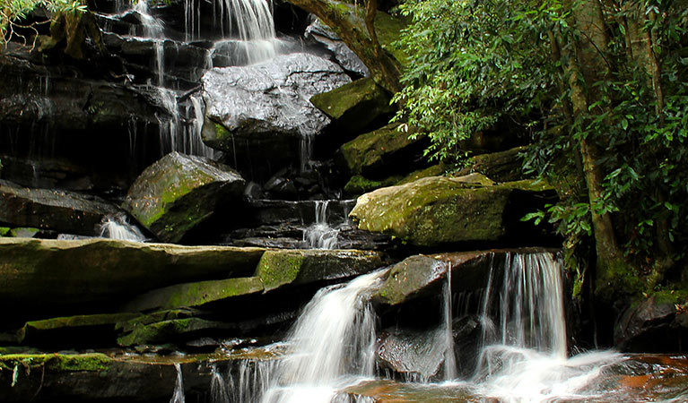
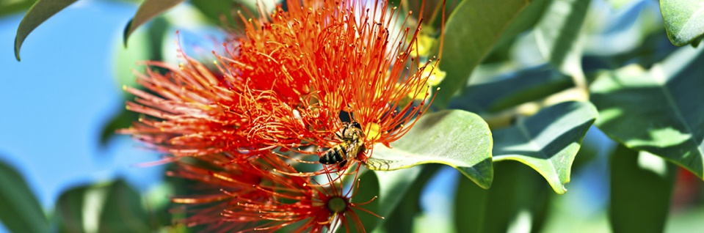
Meet at Somersby Falls Road Entrance at 9am.
http://www.nationalparks.nsw.gov.au/things-to-do/picnic-areas/somersby-falls-picnic-area
Car park Entry Fee: $8 (Can park outside gate if space available)
Once finished waterfall shoot and maybe morning tea we will then head on to Mt Penang Gardens
The Garden is located at: Parklands Road, Mt Penang Parklands, Kariong. Free entry
The Waterfall Café for lunch overlooks the magnificent water cascade gardens and provides light meals and morning or afternoon tea.
Enjoy a family-friendly menu ranging from gourmet sandwiches and salads to sweet treats and snacks.
For more information visit www.waterfallcafe.com.au or call (02) 4340 1660.
http://www.mtpenanggardens.com.au/.
Sensible clothing and footwear is advised. Be prepared for changeable weather conditions
Email Colleen at pricecolleen54@gmail.com or write name and mobile contact on sign on sheet at camera club meeting.

